RESTRICTED LINUX SHELL ESCAPING TECHNIQUES

Restricted shells are no strange to Penetration testers, or Linux administrators, but for some reason its importance is still neglected by many security and IT professionals in general.

Restricted shells are conceptually shells with restricted permissions, with features and commands working under a very peculiar environment, built to keep users in a secure and controlled environment, allowing them just the minimum necessary to perform their daily operations.

Linux administrators generally need to provide a local or remote shell to other users, or administrators, for daily routine management and support procedures, that’s why it is extremely important to restrict these shell’s features to a minimum necessary for this activities, but sometimes it’s just not enough to keep it away from hackers, as you will soon see.

Penetration testers are a very cunning and determined kind of people that will only find peace after hacking into your servers. Once they get a low privileged shell, even a restricted one, it’s time to try to escape normal restrictions and get more features and privileges to play with.

This is where restricted shell escaping techniques come into play. Escaping shell restrictions is just a small part of Penetration Testing Post Exploitation phase, designed to escalate privileges. Keep in mind that bypassing shell restrictions to escalate privileges doesn’t necessarily mean getting write or execution permissions, generally used to get a less restricted shell or root access (which would be desirable), but sometimes it is all about read permissions, allowing us to check files and inspect file system areas that we were not allowed before, to steal sensitive information that wouldn’t be available otherwise. This “read-only” access, always so underestimated, can give us very precious information, such as user and service enumeration, even some credentials, for further attacks and consequently owning the box itself.

* One of the restricted shell escaping techniques is Pager Commands!
Linux pagers are simple utilities that allow us to see the output of a particular command or text file, that is too big to fit the screen, in a paged way. The most well known are “more” and “less”. Pagers also have escape features to execute scripts.
Open a file long enough to fit in more than one screen with any of the pagers above and simply type !’sh’ inside it, as shown below:
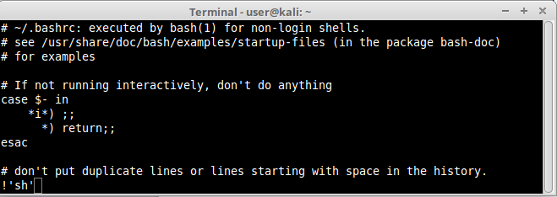
As you can see our example using “less” we’ve managed to open a shell inside our pager and execute restricted commands:.
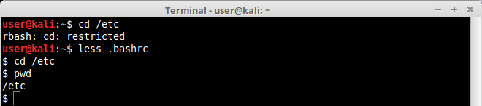
This technique works on both “more” and “less” pagers.

An other example;
–> Assume we permitted a user to edit any txt file (i.e. shh.config file) with 'more' command.
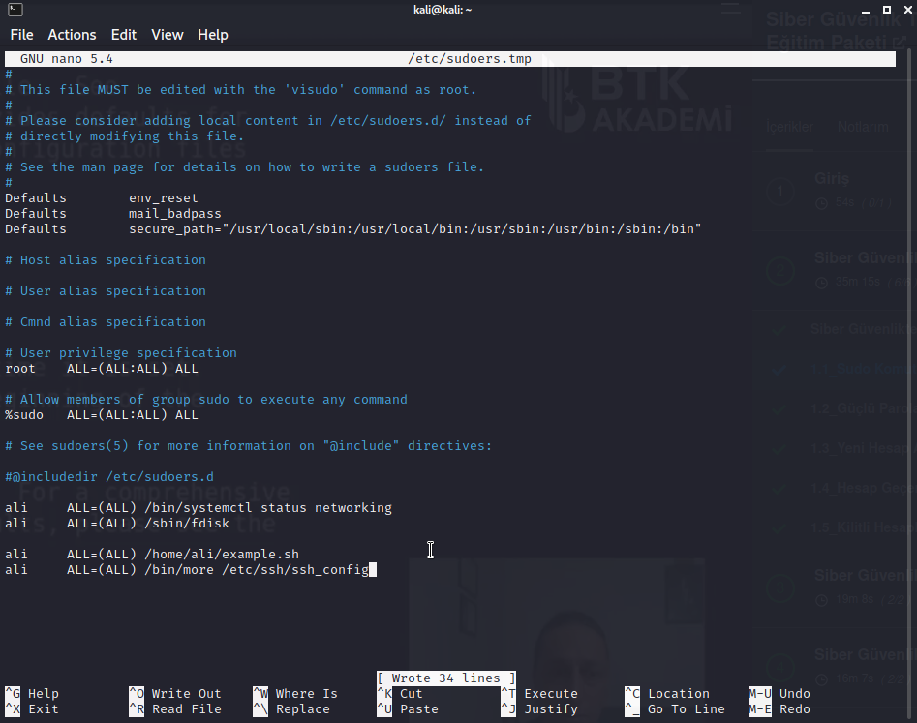

–> Then we switch another user and open the ssh_coning file to edit with ‘more’;
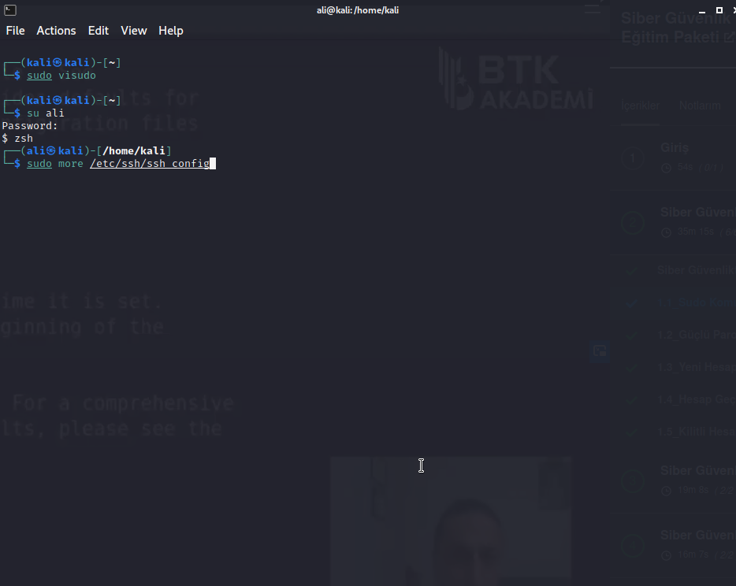

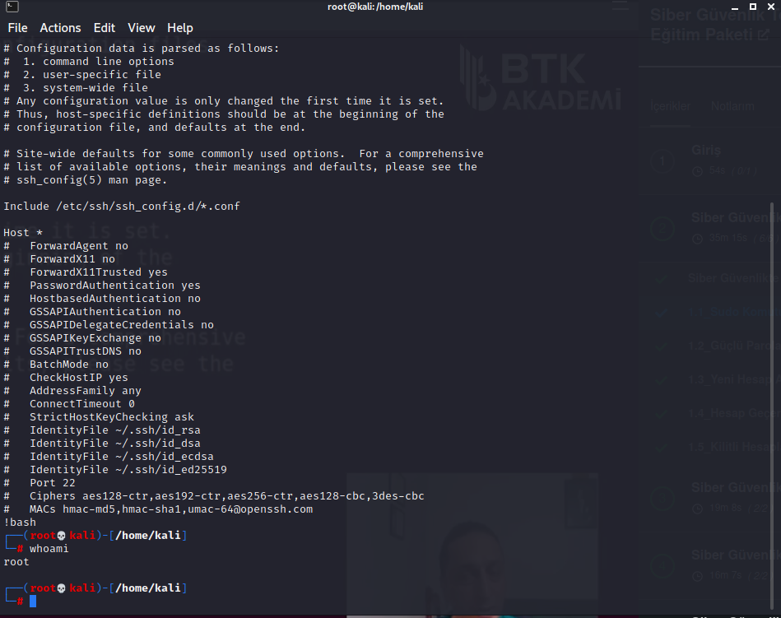
–> Finally; we implement our attack!

*!! As additional; this can be an instance for the escalation privilege attacks!

